

**Digital Media Kit**

Emails

This kit is intended to be a starting point for email campaigns in collaboration with little moments count. Please feel free to use the copy and images, and take it a step further by adding customized messaging to relate to your audience.

Talk Emails

(image):

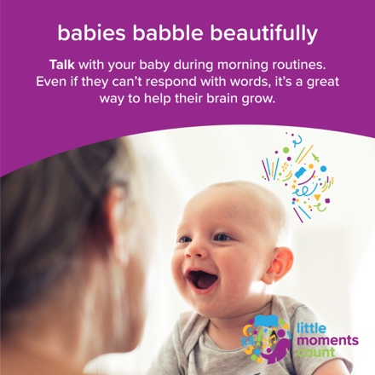

(copy):

Getting your baby dressed in the morning is a great time to have some fun together. Talk your baby through the steps as you get them dressed. Start by naming the pieces of clothing as you put them on. Your baby will begin to recognize what the items are and how to put them on when they can do it by themself. For more information, visit [littlemomentscount.org](http://littlemomentscount.org/).

(image):

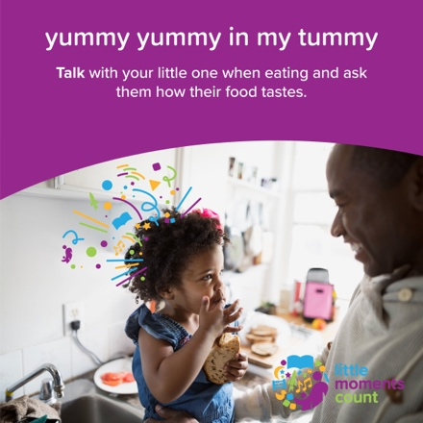

(copy):

When enjoying dinner together, invite your child into the process by talking to them about the food. What color is it? What’s the texture like? How does it taste? Even if they’re not yet using their words, they love to hear yours. For more information, visit [littlemomentscount.org](http://littlemomentscount.org/).

Play Emails

(image):

(copy):

Little ones need to unwind before bedtime. One way to help your child unwind while exploring their creative side is to allow for some unstructured quiet playtime before bed. Not only is this a peaceful activity for them, but it can provide a little moment of peace and quiet in your own evening, too. For more information, visit [littlemomentscount.org](http://littlemomentscount.org/).

(image):

(copy):

Babies learn a lot when they play. It helps to build creativity and confidence. What’s your baby’s favorite way to play? What about their favorite toys? Remember, babies don’t need fancy playthings. Measuring cups can be used as nesting toys, spoons and forks can be sorted, and cotton balls are fun sensory items to facilitate development of grasping and fine motor skills. For more information, visit [littlemomentscount.org](http://littlemomentscount.org/).

Read Emails

(image):

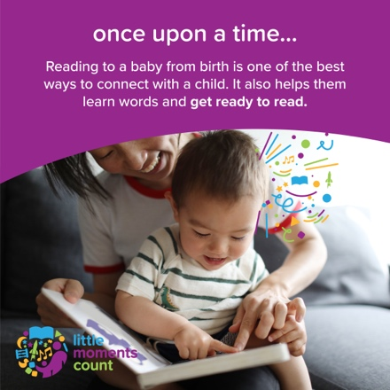

(copy):

Bedtime is full of great little moments to connect with your baby and help them learn. Before going to sleep, try reading a story to your baby but make them the main character. Feel free to create characters for family and friends, too. Reading helps your baby learn new words and build a nightly routine they look forward to. For more information, visit [littlemomentscount.org](http://littlemomentscount.org/).

(image):

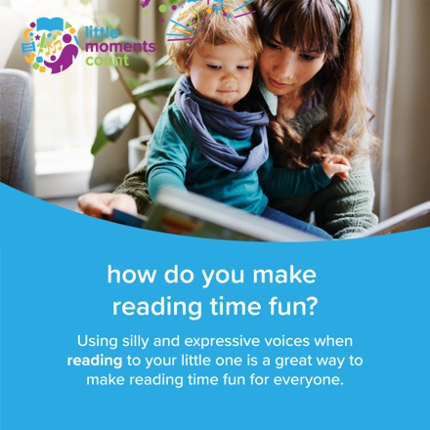

(copy):

Storytelling and reading are fun, and babies learn a lot when they listen. One way to make the most of these little moments is using silly voices for different characters or actions in the book or story you’re telling. When your child sees and hears you having fun, they feel extra happy and enjoy the story even more. For more information, visit [littlemomentscount.org](http://littlemomentscount.org/).

Sing Emails

(image):

(copy):

“Zip, zip your zipper up to your chin, don’t let the cold air in!” Silly songs are a fun way to build a baby's memory and bond with them. Sing different songs with your baby while doing everyday tasks, like zipping up their jacket or giving them a bath. For more information, visit [littlemomentscount.org](http://littlemomentscount.org/).

(image):

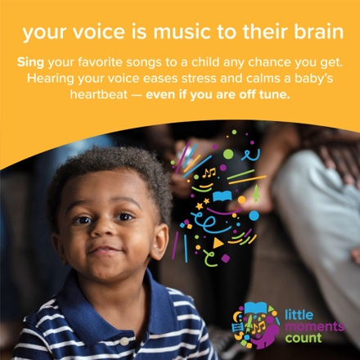

(copy):

Did you know that babies love a good beat? Singing helps babies learn new words, language and communication skills, plus it can be a great way to have some fun together! Babies love music. Try throwing on a song from the little moments count playlist and see what music your baby responds to. [https://open.spotify.com/playlist/4zQ03bu31wrqURZEmXSoSZ](https://open.spotify.com/playlist/4zQ03bu31wrqURZEmXSoSZ?fbclid=IwAR03a36XOJdSFxbmWuEoIKR3wFTmlvD7fnN0G48wLGvNXN1YpxAGRvSLKRk)

For more information, visit [littlemomentscount.org](http://littlemomentscount.org/).

Racial Disparities Emails

(image):

(copy):

It’s never too early to talk about race with your little one. To help inform these conversations, it’s important for parents and caretakers to learn about racial and social justice. On the website [littlemomentscount.org](http://littlemomentscount.org/?fbclid=IwAR0fI012wbDo29CVUvOjCKvZniGYtfoF2MIC1IPSFpVSR5pGQDTsMOaTZms) you’ll find tools that can be read, watched, listened to, and acted on, as we work collectively to fight against racism and raise children who respect and celebrate people from all backgrounds.

(image):

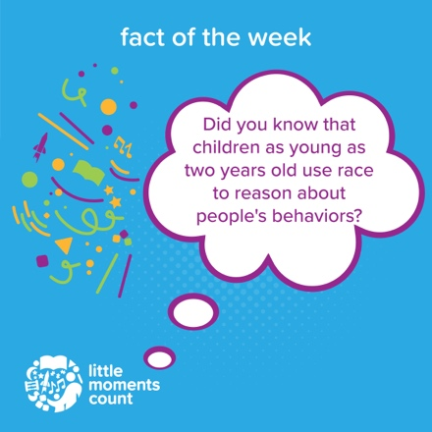

(copy):

There’s a myth in popular culture that children are a blank slate and don’t notice race. But this isn’t true as children can start to form their own racial biases as early as two years old. Having conversations with your little one about race is a great way to highlight how each of our differences makes us unique. Instead of shushing them for inappropriate comments, try redirecting their thought process from “that person is different than me” to “this person is special and has their own qualities, just like us” ” For resources on how to talk about race with your little one, visit [littlemomentscount.org/racial-justice-resources](https://www.littlemomentscount.org/racial-justice-resources).