

**Digital Media Kit**

Social Media

This kit is intended to be a starting point for social media posts in collaboration with little moments count. Please feel free to use the copy and images, and take it a step further by adding customized messaging to relate to your audience.

General Posts

(image):

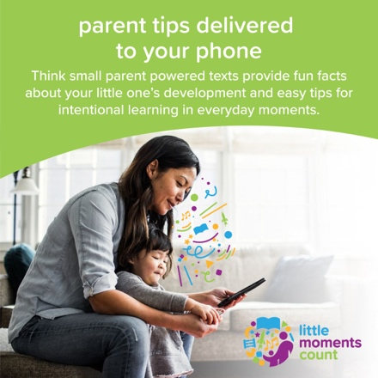

(copy):

Want more facts and tips for making the most of your little moments? Sign up for [Think Small](https://www.facebook.com/ThinkSmallEarlyLearning/?__cft__%5b0%5d=AZVnWwPOfP2557fd3MnC8qLFgG591ZrL4NXkFIDAmWWRshjHoO5Y7_wEfFNWwdHEPOtIW1b5BEWbQSKKpKLcDKIWkyZzpe-cvfpxjvCEpNUWMArujE736n6M66nHkvuGs-F_NOeYpMhOgFU5yDw6xoZy&__tn__=kK-R) Parent Powered texts -- it’s free! You’ll get fun facts about your child’s development, plus easy to use tips for intentional learning in everyday moments like snack time, going to the store, or getting ready for bed. Sign up today by texting LMC to 70138. Use code LMC ESP to receive messages in Spanish and LMC SOM for Somali.

(video):

<https://www.facebook.com/102638364513604/videos/460922085047362>

(copy):

Talking, playing, reading and singing to your baby even for little moments can make a big difference in their brain development. Explore how you can make little moments count to help your baby’s brain grow and to strengthen your relationship.

Talk Posts

(image):

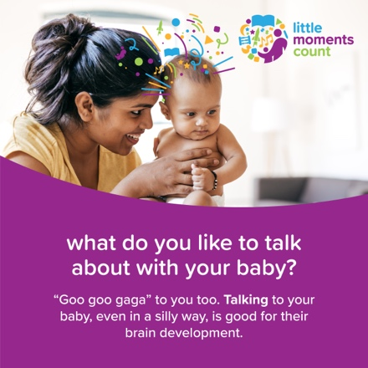

(copy):

Babies love to talk, even though they’re mostly using sounds, not words. It’s good for them too. What do you like to talk about with your baby? Let us know in the comments. [#littlemomentscountmn](https://www.facebook.com/hashtag/littlemomentscountmn)

(image):

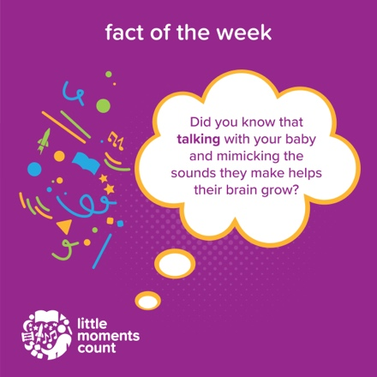

(copy):

Did you know that mimicking the sounds your baby makes helps them learn? By copying their sounds, you’re showing them that conversation is a back-and-forth effort!

Play Posts

(image):

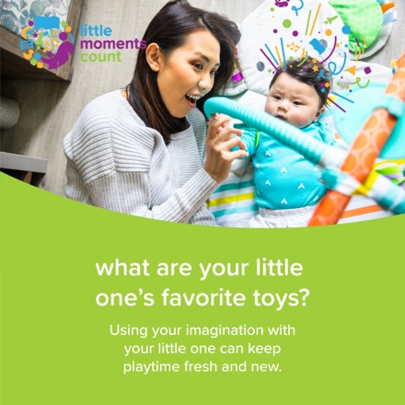

(copy):

Variety is the key to keeping play time fun and new. Try making a treasure basket with different babyproof objects for your baby to play with and examine. What is your baby drawn to? What objects did they put together? [#littlemomentscountmn](https://www.facebook.com/hashtag/littlemomentscountmn)

(image):

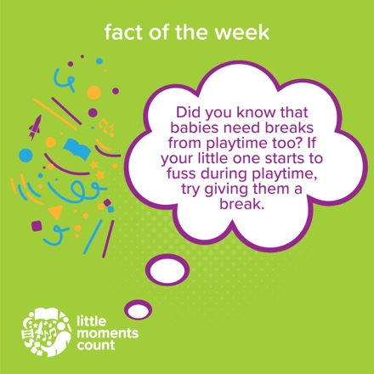

(copy):

Babies love to play, but it can be overstimulating too. Did you know babies need breaks just like adults do?

When your baby turns their head away, or starts to fuss during play time, try giving them a break. It could be removing their toys and letting them snooze, or try picking them up for a swaddle so that they can calm down and regroup. [[#littlemomentscount](https://www.facebook.com/hashtag/littlemomentscount?__eep__=6&__cft__%5b0%5d=AZUsYUSN6LA4x5F2j4YEuh-gpoKuwpTGvjALdFblzQGcpigVanHyVKW5QcmpZj51yOEt1cIZDeLI2TB0AMJdUw3BXlxR_kwMxY8IuhzC-yYFA7IkiOTwYv3tAlys6jPANtNd2wBpxrTyXbIfc2m0QaEr&__tn__=*NK-R)mn](https://www.facebook.com/hashtag/littlemomentscountmn) [#factoftheweek](https://www.facebook.com/hashtag/factoftheweek?__eep__=6&__cft__%5b0%5d=AZUsYUSN6LA4x5F2j4YEuh-gpoKuwpTGvjALdFblzQGcpigVanHyVKW5QcmpZj51yOEt1cIZDeLI2TB0AMJdUw3BXlxR_kwMxY8IuhzC-yYFA7IkiOTwYv3tAlys6jPANtNd2wBpxrTyXbIfc2m0QaEr&__tn__=*NK-R)

Read Posts

(image):



(copy):

Telling stories and reading helps build a baby’s memory. Do you like to tell stories or read to your baby? What are some of their favorites? Let us know in the comments. [#littlemomentscount](https://www.facebook.com/hashtag/littlemomentscount?__eep__=6&__cft__%5b0%5d=AZXxbV4WwhzPFBr1KdtxKgIZvS9-G1a40TEXv_PsaTLq8zl4F5IJkO59Ak4xpGofc9C-hdm1ZUC-pDhBr9ve5hScWjR0PNvujOW2myZN4V18ogAiEvO-YbSMcIIAfrUUP5myWGcIuph8e62p0VOO4qC3&__tn__=*NK-R)mn

(image):

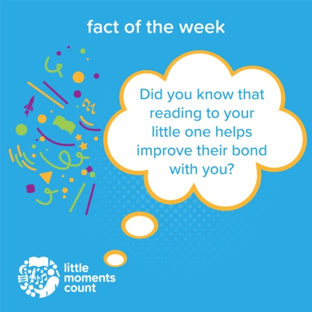

(copy):

Babies learn a lot from having stories told or read to them. Reading supports emotional learning -- how to form friendships, communicate emotions, and develop trust, empathy and compassion as they grow all while helping them bond with you too. Snuggle up for story time anytime. Closeness and one-on-one time strengthens your baby’s bond to you. Plus, it can be an incredible way to relax with your baby at the end of the day.

[#factoftheweek](https://www.facebook.com/hashtag/factoftheweek?__eep__=6&__cft__%5b0%5d=AZUsYUSN6LA4x5F2j4YEuh-gpoKuwpTGvjALdFblzQGcpigVanHyVKW5QcmpZj51yOEt1cIZDeLI2TB0AMJdUw3BXlxR_kwMxY8IuhzC-yYFA7IkiOTwYv3tAlys6jPANtNd2wBpxrTyXbIfc2m0QaEr&__tn__=*NK-R) [#littlemomentscount](https://www.facebook.com/hashtag/littlemomentscount?__eep__=6&__cft__%5b0%5d=AZUsYUSN6LA4x5F2j4YEuh-gpoKuwpTGvjALdFblzQGcpigVanHyVKW5QcmpZj51yOEt1cIZDeLI2TB0AMJdUw3BXlxR_kwMxY8IuhzC-yYFA7IkiOTwYv3tAlys6jPANtNd2wBpxrTyXbIfc2m0QaEr&__tn__=*NK-R)mn

Sing Posts

(image):

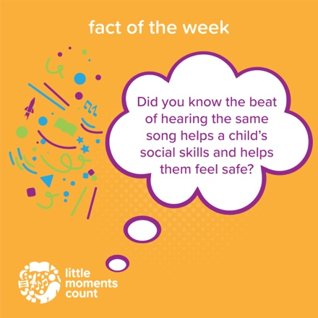

(copy):

Babies feel safe when life is predictable. Did you know that singing can help foster that feeling of safety?

Try singing to your baby when switching between daily tasks so that they can start to learn what comes next throughout their day. [#factoftheweek](https://www.facebook.com/hashtag/factoftheweek?__eep__=6&__cft__%5b0%5d=AZXNk8RtcIM4ZbO5mw3n_2dvPyoacjdB99OeR5ZOmEb5Nt2MKLVGU8T1fs_oi2uUdFR3yFClCXTV4R9_GI_rGwMiQWPuKzk9_2vqj6-5oYW778Ndt9Hq9BKl_M0P8ZGGf7Oiu2aTZX68wGeeLwh_nXdF&__tn__=*NK-R) [#littlemomentscount](https://www.facebook.com/hashtag/littlemomentscount?__eep__=6&__cft__%5b0%5d=AZXNk8RtcIM4ZbO5mw3n_2dvPyoacjdB99OeR5ZOmEb5Nt2MKLVGU8T1fs_oi2uUdFR3yFClCXTV4R9_GI_rGwMiQWPuKzk9_2vqj6-5oYW778Ndt9Hq9BKl_M0P8ZGGf7Oiu2aTZX68wGeeLwh_nXdF&__tn__=*NK-R)mn

(image):

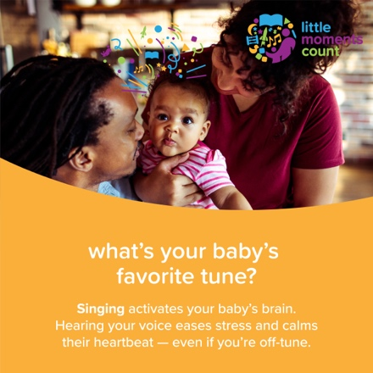

(copy):

Singing activates a baby’s brain, even if you aren’t a star singer. Do you sing to your baby? If so, what are some songs you sing? Let us know in the comments. And check out this playlist from Little Moments Count: [https://open.spotify.com/playlist/4zQ03bu31wrqURZEmXSoSZ](https://open.spotify.com/playlist/4zQ03bu31wrqURZEmXSoSZ?fbclid=IwAR10wt3dN_pJG1GL_lC8O8IDA9mLwZT2qCQSNQWlFCWEUtcmM2CUHzptxy4) [#littlemomentscountmn](https://www.facebook.com/hashtag/littlemomentscountmn)

Racial Disparities Posts

(image):

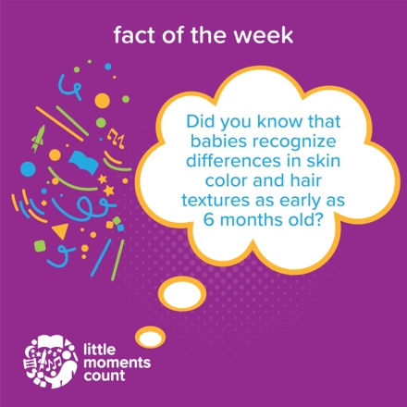

(copy):

While it’s important to talk about physical differences, you should also call attention to the special talents inherent in diversity. You can try something like “Everybody is special, and so-and-so is special because his/her family can speak another language." [#littlemomentscountmn](https://www.facebook.com/hashtag/littlemomentscountmn) [#FactoftheWeek](https://www.facebook.com/hashtag/factoftheweek?__eep__=6&__cft__%5b0%5d=AZWtKFRSJdt_SJLrblooOlSIo3xxJuh_Cl80O66eeU5PXdl_dPzPOZFpn-Qp36deRXnyC-oeL2G0QSVAQAmcrbZk5fCBjm7ypEhahfvvMS80dxd-Vi7HLUfuTBmY2jhqXUieyYaY58AuY2ccJNACJbeB&__tn__=*NK-R)

(image):

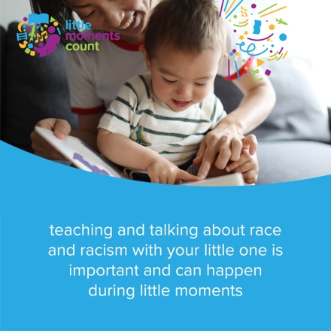

(copy):

Whether it's during your morning routine or on the way to the grocery store, there are plenty of little moments where you can talk with your child about race and racism. On [littlemomentscount.org/racial-justice-resources](https://www.littlemomentscount.org/racial-justice-resources) you’ll find videos, books, podcasts, and more for ways to bring racial awareness into everyday activities. Do you have a favorite way to bring these conversations into your home? Let us know in the comments so that we can share ideas and connect on these very important conversations. [#littlemomentscountmn](https://www.facebook.com/hashtag/littlemomentscountmn)