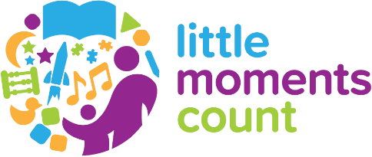
TO: All colleagues
FROM: Leader name and title
DATE:
RE: Introducing Little Moments Count

Talking, playing, reading and singing with the small children in our lives is great fun. But did you know that it’s also one of the best things you can do to help give kids ages 0-3 a great start in life?
It’s true. Little moments like counting stairs with kids or swinging alongside them at the park is building their brains.
In the coming (days/weeks/months), you’ll see short, creative messages and activities that spark new ideas and show how fun and simple it is to have brain-building moments with young children.
It’s all part of Little Moments Count, a community campaign we’re promoting in partnership with many other local organizations. The collaboration is focused on a shared commitment to advocate the benefits of talking, playing, reading and singing with children from day one.
This work will help lay a foundation that will benefit generations to come. I want to thank the many community, internal and organizational partners who have lent their passion, imagination and dedication to creating the work you’ll be seeing.
And also thank you for all of the “little moments” you make happen here in our organization, in our community and in your family. Together, we’ll help pave the way for a stronger, healthier future for children.

With gratitude,
Signature

